

**Jashore University of Science and Technology**

**Department of Computer Science and Engineering**

**Course Title: Database Systems Laboratory**

**Course Code: CSE-2204**

|  |
| --- |
| **A Lab Report**  **On**  **Bookshop** |

|  |  |
| --- | --- |
| Submitted to | Submitted by |
| Atish Kumar Dipongkor  Lecturer,  Department Computer Science and Engineering  Jashore University of Science and Technology. | Name: Md. Moradul Siddique  Roll : 170144  2nd Year 2st Semester  Session: 2017-2018  Dept. of Computer Science and Engineering  Jashore University of Science and Technology. |

|  |
| --- |
| Remarks |
|  |

Date of Submission: 28-09-2019

**Book Shop Database Systems**

**System Overview:**

Customer wants to purchase any book from the shop than first of all customer just choose the stream of the book than he/she can see the more than one type of books there and then he/she can choose the specific book from there. And then purchase it by paying price on bookshop cash counter and receives its invoice. We are concerning the manual process of a bookshop, the major problem is the waste of time. A customer has to waste his/her valuable time when he needs to buy a book as all the events such as searching, purchasing are done by members of the staff .In briefly, the manual process is very slow. But automation will reduce the time taken in the whole process. The Bookshop System is to automate some operations in a bookshop. Generally it includes the Order Processing, Stock Management.

**Existing system description:**

At present, the Wholesale and Retail outlets are working under manual management. All records related to Products, Sales, Suppliers, Orders, Payment are stored in registers. To manage the whole data, the person maintaining records has to take great pain. Various registers has to be maintained for each separate process. I try to develop such type system which is provide the automation on the any type of the bookshop. That means a shop which has the type system which provides the facility to the customers of the shop to purchase the books from the shop without any complexity.

**Reduce of work:**

* Automation of existing manual information systems.
* Reduction of manual processing.
* Decrease in processing time.
* Fast retrieval of all type of information.
* Good efficiency and response time.
* More consistent data handling.
* A user-friendly system which do not require any special training or Expertise of computer.

**Entity:**

books

authors

publishers

genres

books_genres

customers

discounts

books_discounts

customers_discounts

shippers

orders

orders_details

reviews

**Entity with Attribute and Keys:**

|  |  |
| --- | --- |
| **books** |  |
| Isbn | varchar |
| title | varchar |
| publicatiom_date | date |
| edition | integer |
| Available_quantity | integer |
| price | numeric |
| author | integer |
| publisher | integer |
|  |  |

Superkey:{{Isbn},{Isbn,tilte},{Isbn,publication_date},{Isbn,edition},{Isbn,Available_quantity}{Isbn,price},{Isbn,author},{Isbn,publisher},{Isbn,tilte},{Isbn,publication_date},{Isbn,tilte,edition},{Isbn,tilte,Available_quantity},{Isbn,tilte,price},{Isbn,tilte,author},{Isbn,tilte,publisher},{Isbn,publication_date,edition},{Isbn,publicatiom_date,Available_quantity},{Isbn,publication_date,price},{Isbn,publication_date,author},{Isbn,publication_date,publisher},{Isbn,edition,Available_quantity},{Isbn,edition,price},{Isbn,edition,author},{Isbn,edition,publisher},{Isbn,Available_quantity,price},{Isbn,Available_quantity,author},{Isbn,Available_quantity,publisher},{Isbn,price,author},{Isbn,price,publisher},{Isbn,author,publisher},

{Isbn,tilte,pubication_date,edition},{Isbn,tilte,publication_date,Available_quantity},{Isbn,tilte,publication_date,price},{Isbn,tilte,publicatiom_date,author},{Isbn,tilte,publicatiom_date,publisher},{Isbn,publicatiom_date,edition,Available_quantity},{Isbn,publication_date,edition,price},{Isbn,publication_date,edition,aothor},{Isbn,publication_date,edition,publisher},{Isbn,edition,Available_quantity,price},{Isbn,,edition,Available_quantity,author},{Isbn,,edition,Available_quantity,publisher},{Isbn,Availble_quantity,price,author},{Isbn,Availble_quantity,price,publisher},},{Isbn,price,author,publisher},{Isbn,title,publication_date,edition,Available_quantity},{Isbn,title,publicatiom_date,edition,price},{Isbn,title,publication_date,edition,author},{Isbn,title,publication_date,edition,publisher},{Isbn,publication_date,edition,Availble_quantity,price},{Isbn,publication_date,edition,Available_quanitity,author},{Isbn,publication_date,edition,Available_quanitity,publisher},{Isbn,edition,Available_quanitity,price,author},{Isbn,edition,Available_quanitity,price,publisher},{Isbn,Available_quanitity,price,author,publisher},{Isbn,title,publication_date,edition,Available_quanitity,price},{Isbn,title,publication_date,edition,Available_quanitity,author},{Isbn,title,publication_date,edition,Available_quanitity,publisher},{Isbn,publication_date,edition,Available_quanitity,author,publiher},{Isbn,title,publication_date,edition,Available_quanitity,price,author},{Isbn,title,publication_date,edition,Available_quanitity,price,publisher},{Isbn,title,publication_date,edition,Available_quanitity,price,author,publisher}}

Primary key: {Isbn}

Foreign key: author, publisher

CREATE INDEX ind_bk *ON*books*(*author)

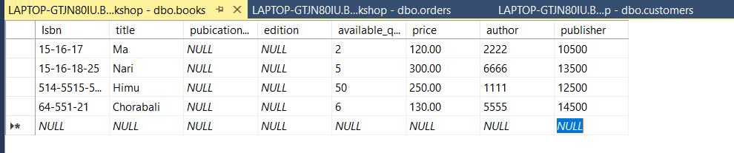

Fig: Inserted data in books table

|  |  |
| --- | --- |
| **authors** |  |
| id | integer |
| First_name | varchar |
| Second_name | char |
| Company_name | char |

Superkey:{{id},{id,first_name},{id,second_name},{id,company_name},{id,first_name,second_name},{id,first_name,Company_name},{id,first_name, second_name, company_name}}

Primary key:{id}

CREATE INDEXind_authorONauthors(First_name)

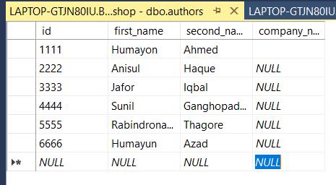

Fig: Inserted data in authors table

|  |  |
| --- | --- |
| **publishers** |  |
| id | integer |
| name | char |

Super key: {{id},{id, name}}

Primary key: {id}

CREATE INDEXind_publisherONpublishers*(name*)

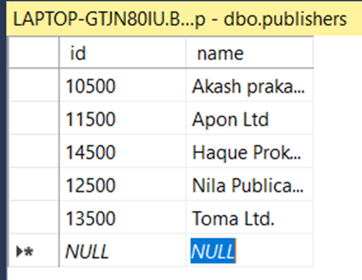

Fig: Inserted data in publishers table

|  |  |
| --- | --- |
| **customers** |  |
| id | integer |
| first_name | varchar |
| last_name | varchar |
| login | varchar |
| password | varchar |
| postal_code | varchar |
| street | varchar |
| building_no | varchar |
| flat_no | varchar |
| city | varchar |
| NID | varchar |
| phone_number | varchar |

Super Key:{id}{NID},{phone_number},{login,passward},{id, first_name },{id, last_name },{id, login },{id, password },{id, postal_code },{id, street },{id, building_no },{id, flat_no },{id, city },{id, NID },{id, phone_number },{NID,first_name},{ NID, last_name },{ NID, login },{ NID, password },{ NID, postal_code },{ NID, street },{ NID, building_no },{ NID, flat_no},{NID,city},{NID,phone_number},{phone_number,first_name},{phone_number,last_name },{phone_number,login},{phone_number, password},{phone_number, postal_code },{phone_number,street},{phone_number,building_no},{phone_number,flat_no},{phone_number, city },{id,login,passward},{login,passward, first_name },{login,passward, last_name },{login,passward,postal_code},{login,passward,street},{login,passward,building_no},{login,passward,flat_no},{login,passward,city},{login,passward,NID}{login,passward,phone_number}{ id, first_name, last_name },{ id, first_name, login },{ id, first_name, password },{ id, first_name, postal_code},{id, first_name,street},{id,first_name,building_no },{id, first_name, flat_no},{ id, first_name, city},{id, first_name, NID },{id, first_name, phone_number },{ id, last_name,login},{id,last_name,password},{id,last_name,postal_code},{id,last_name,street},{id, last_name,building_no},{id, last_name, flat_no},{id,last_name, city},{id, last_name, NID },{id,last_name,phone_number},{id,login,postal_code},{id,login,street},{id,login,building_no },{id,login, flat_no },{id,login, city },{id,login, NID },{id,login, phone_number }

Primary key: id

CREATE INDEX ind_customers  
ON customers (phone_number)

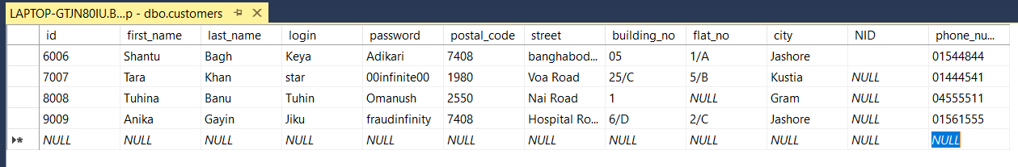

Fig: Inserted data in customers table

|  |  |
| --- | --- |
| **genres** |  |
| id | integer |
| name | varchar |

Super key:{{id},{id, name}}

Primary key: {id}

CREATE INDEX ind_genreONgenres*(name*)

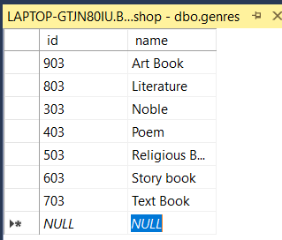

Fig: Inserted data in genres table

|  |  |
| --- | --- |
| **book_genres** |  |
| book_id | varchar |
| genre_id | integer |

Super key: {{book_id, genre_id}}

Composite key: {book_id, genre_id}

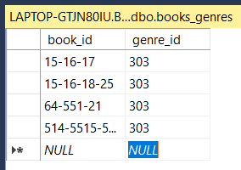

Fig: Inserted data in book_genres table

|  |  |
| --- | --- |
| **discount** |  |
| id | integer |
| name | varchar |
| value | numeric |

Super key: {{id},{id,name},{id,value},{id,name,,value}}

Primary key: {id}

CREATE INDEX ind_discountON discount*(name*)

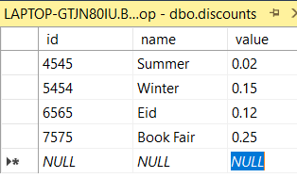

Fig: Inserted data in discounts table

|  |  |
| --- | --- |
| **customers_discount** |  |
| customer_id | integer |
| discount_id | integer |

Super key: {customer_id, discount_id}

Composite key: {customer_id, discount_id}

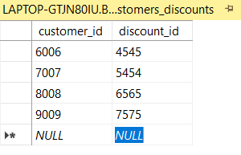

Fig: Inserted data in customers_discount table

|  |  |
| --- | --- |
| **books_discount** |  |
| book_id | varchar |
| discount_id | integer |

Super key: {{book_id, discount_id}}

Primary key as Composite key: {book_id, discount_id}

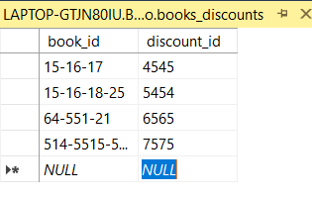

Fig: Inserted data in book_discount table

|  |  |
| --- | --- |
| **orders** |  |
| id | integer |
| customer_id | integer |
| date | date |
| discount_id | bigint |
| shipper | bigint |
| state | varchar |

Super key:{{id}.{id, customer_id },{id, date },{id, discount_id },{id, shipper},{id, state}, {id, customer_id,date},{id,customer_id,discount_id},{id, customer_id , shipper },{id, customer_id ,state},{id,date,discount_id},{id,date,shipper},{id,date,state},{id,discount_id,shipper},{id,discount_id,state},{id,shipper,state},{id,customer_id,date,discount_id},{id,date,discount_id,shipper},{id,discount_id,shipper,state},{id,customer_id,date,discount_id,shipper},{id,customer_id,date,discount_id,state},{id,customer_id,date,discount_id,sipper,state}}

Primary key:{id}

Foreign key:{ customer_id},{ discount_id },{shipper}

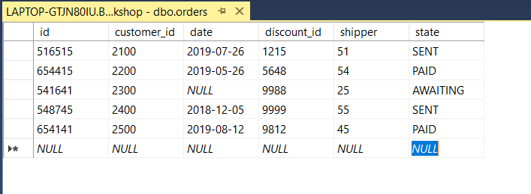

Fig: Inserted data in orders table

|  |  |
| --- | --- |
| **orders_details** |  |
| book_id | varchar |
| order_id | bigint |
| amount | integer |

Superkey:{{book_id,order_id},{order_id,amount},{order_id,amount},{book_id,order_id,amount}}

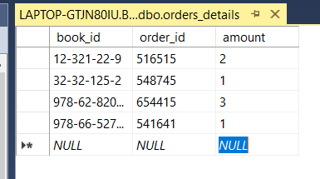

Fig: Inserted data in orders_details table

|  |  |
| --- | --- |
| **shipper** |  |
| id | integer |
| name | varchar |
| Phone_number | integer |

Super key:{{id},{id,name},{id,Phone_number},{id,name,Phone_number}}

Primary key:{id}

CREATE INDEX ind_shipperONshipper*(name*)

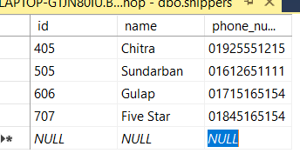

Fig: Inserted data in orders table

|  |  |
| --- | --- |
| **Reviews** |  |
| Id | integer |
| book_id | varchar |
| Customer_id | bigint |
| Review | integer |
| Date | date |
| Comments | varchar |

Superkey:{{id},{id,book_id},{id,Customer_id},{id,Date},{id,Review},{book_id,Customer_i},{id,book_id,Customer_i},{id,book_id,Review},{id,book_id,Date },{id,book_id,Customer_i,Review },{id,book_id,Customer_i, Date },{id,book_id,Customer_i, Review ,Date }}

Primary key: {id}

Foreign key: { book_id} ,{ Customer_id}

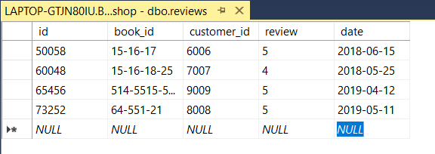

**Schema Diagram:**

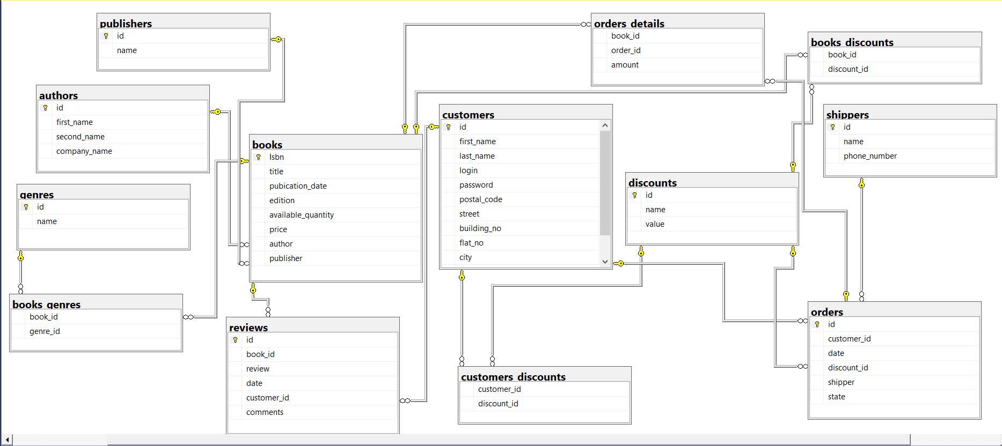

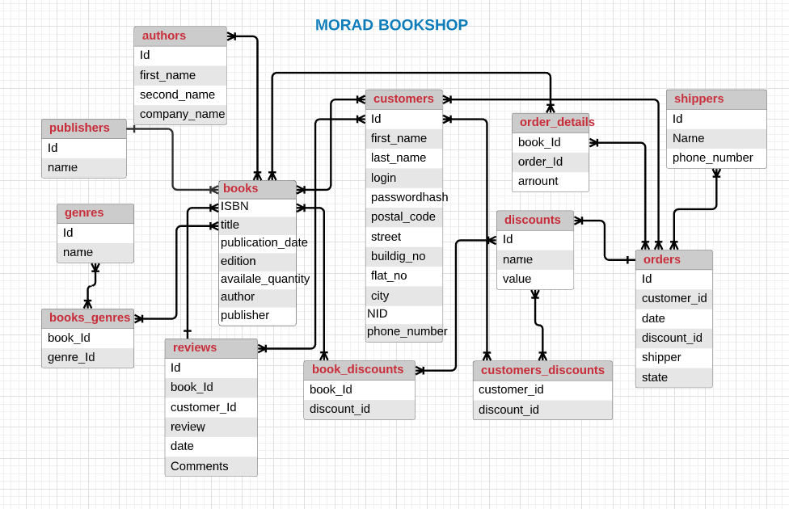

**ERD:**

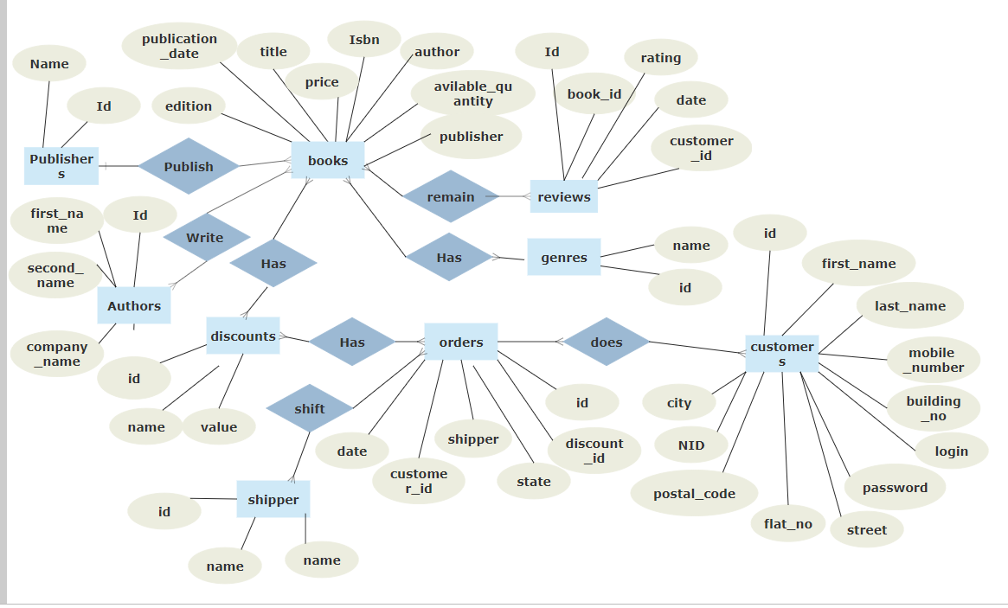

**Normalization:**

All table contains an atomic value so they are satisfy 1NF

All non-key attributes are fully functional dependent on the primary key so they are satisfy 2 NF

There is no transitive dependency for non-prime attributes so they are satisfy 3NF and also satisfy BCNF.

**Query:**

Create database MoradBookshop

CREATE TABLE [authors](

[id] [int] IDENTITY(1,1) NOT NULL,

[first_name] [varchar](100) NULL,

[second_name] [varchar](100) NULL,

[company_name] [varchar](100) NULL,

CONSTRAINT [PK_authors] PRIMARY KEY (id)

);

CREATE TABLE [books](

[Isbn] [varchar](100) NOT NULL,

[title] [varchar](100) NULL,

[pubication_date] [date] NULL,

[edition] [int] NULL,

[available_quantity] [int] NULL,

[price] [numeric](6, 2) NULL,

[author] [int] NOT NULL,

[publisher] [int] NULL,

CONSTRAINT [PK_books] PRIMARY KEY(Isbn)

);

ALTER TABLE [books]

ADD CONSTRAINT [FK_books_author_id] FOREIGN KEY ([author]) REFERENCES authors([id])

ON DELETE CASCADE --{ NO ACTION | CASCADE | SET NULL | SET DEFAULT };

CREATE TABLE [publishers](

[id] [int] IDENTITY(1,1) NOT NULL,

[name] [varchar](100) NOT NULL,

CONSTRAINT [PK_publishers] PRIMARY KEY (id)

);

ALTER TABLE [books]

ADD CONSTRAINT [FK_books_publisher_id] FOREIGN KEY ([publisher]) REFERENCES publishers([id])

ON DELETE CASCADE --{ NO ACTION | CASCADE | SET NULL | SET DEFAULT };

CREATE TABLE [books_genres](

[book_id] [varchar](100) NOT NULL,

[genre_id] [int] NOT NULL

);

CREATE TABLE [genres](

[id] [int] IDENTITY(1,1) NOT NULL,

[name] [varchar](100) NOT NULL,

CONSTRAINT [PK_genres] PRIMARY KEY (id)

);

ALTER TABLE [books_genres]

ADD CONSTRAINT [FK_books_genres_id] FOREIGN KEY ([genre_id]) REFERENCES genres([id])

ON DELETE CASCADE --{ NO ACTION | CASCADE | SET NULL | SET DEFAULT };

ALTER TABLE [books_genres]

ADD CONSTRAINT [FK_books_id_Isbn] FOREIGN KEY ([book_id]) REFERENCES books([Isbn])

ON DELETE CASCADE --{ NO ACTION | CASCADE | SET NULL | SET DEFAULT };

CREATE TABLE [customers](

[id] [int] IDENTITY(1,1) NOT NULL,

[first_name] [varchar](100) NOT NULL,

[last_name] [varchar](100) NOT NULL,

[login] [varchar](100) NOT NULL,

[password] [varchar](100) NOT NULL,

[postal_code] [varchar](6) NOT NULL,

[street] [varchar](100) NOT NULL,

[building_no] [varchar](5) NOT NULL,

[flat_no] [varchar](5) NULL,

[city] [varchar](100) NOT NULL,

[NID] [varchar](20) NULL,

[mobile_number] [varchar](20) NOT NULL,

CONSTRAINT [pk_customers] PRIMARY KEY (id)

);

CREATE TABLE [reviews](

[id] [int] IDENTITY(1,1) NOT NULL,

[book_id] [varchar](100) NOt NULL,

[review] [int] NULL,

[date] [date] NULL,

[customer_id] [int] NOT NULL,

[comments] [varchar](500) NULL,

CONSTRAINT [PK__reviews__3213E83F6623B4AB] PRIMARY KEY(id)

);

ALTER TABLE [reviews]

ADD CONSTRAINT [FK_books_book_id_Isbn] FOREIGN KEY ([book_id]) REFERENCES books([Isbn])

ON DELETE CASCADE --{ NO ACTION | CASCADE | SET NULL | SET DEFAULT };

ALTER TABLE [reviews]

ADD CONSTRAINT [FK_customers_customers_id] FOREIGN KEY ([customer_id]) REFERENCES customers([id])

ON DELETE CASCADE --{ NO ACTION | CASCADE | SET NULL | SET DEFAULT };

CREATE TABLE [orders](

[id] [int] IDENTITY(1,1) NOT NULL,

[customer_id] [int] NOT NULL,

[date] [date] NULL,

[discount_id] [int] NOT NULL,

[shipper] [int] NOT NULL,

[state] [varchar](650) NULL,

CONSTRAINT [PK__orders__id] PRIMARY KEY(id)

);

CREATE TABLE [discounts](

[id] [int] IDENTITY(1,1) NOT NULL,

[name] [varchar](100) NULL,

[value] [numeric](2, 2) NULL,

CONSTRAINT [PK_discounts__discounts__id] PRIMARY KEY(id)

);

CREATE TABLE [shippers](

[id] [int] identity(1,1) NOT NULL,

[name] [varchar](100) NOT NULL,

[phone_number] [varchar](20) NOT NULL,

CONSTRAINT [shippers__shipper__id] PRIMARY KEY(id)

);

ALTER TABLE [orders]

ADD CONSTRAINT [FK_shippers_shipper_id] FOREIGN KEY ([shipper]) REFERENCES shippers([id])

ON DELETE CASCADE --{ NO ACTION | CASCADE | SET NULL | SET DEFAULT };

ALTER TABLE [orders]

ADD CONSTRAINT [FK_customers_customer_id] FOREIGN KEY ([customer_id]) REFERENCES customers([id])

ON DELETE CASCADE --{ NO ACTION | CASCADE | SET NULL | SET DEFAULT };

ALTER TABLE [orders]

ADD CONSTRAINT [FK_discounts_discount_id] FOREIGN KEY ([discount_id]) REFERENCES discounts([id])

ON DELETE CASCADE --{ NO ACTION | CASCADE | SET NULL | SET DEFAULT };

CREATE TABLE [orders_details](

[book_id] [varchar](100) NOT NULL,

[order_id] [int] NOT NULL,

[amount] [int] NULL

);

ALTER TABLE [orders_details]

ADD CONSTRAINT [FK_books_book_id] FOREIGN KEY ([book_id]) REFERENCES books([Isbn])

ON DELETE CASCADE --{ NO ACTION | CASCADE | SET NULL | SET DEFAULT };

ALTER TABLE [orders_details]

ADD CONSTRAINT [FK_orders_order_id] FOREIGN KEY ([order_id]) REFERENCES orders([id])

ON DELETE CASCADE --{ NO ACTION | CASCADE | SET NULL | SET DEFAULT };

CREATE TABLE [customers_discounts](

[customer_id] [int] NOT NULL,

[discount_id] [int] NOT NULL

);

ALTER TABLE [customers_discounts]

ADD CONSTRAINT [discounts_discount_id] FOREIGN KEY ([discount_id]) REFERENCES discounts([id])

ON DELETE CASCADE --{ NO ACTION | CASCADE | SET NULL | SET DEFAULT };

ALTER TABLE [customers_discounts]

ADD CONSTRAINT [FK_customer_customers_id] FOREIGN KEY ([customer_id]) REFERENCES customers([id])

ON DELETE CASCADE --{ NO ACTION | CASCADE | SET NULL | SET DEFAULT };

CREATE TABLE [books_discounts](

[book_id] [varchar](100) NOT NULL,

[discount_id] [int] NOT NULL

);

ALTER TABLE [books_discounts]

ADD CONSTRAINT [FK_discount_discounts_id] FOREIGN KEY ([discount_id]) REFERENCES discounts([id])

ON DELETE CASCADE --{ NO ACTION | CASCADE | SET NULL | SET DEFAULT };

ALTER TABLE [books_discounts]

ADD CONSTRAINT [FK_books_books_id] FOREIGN KEY ([book_id]) REFERENCES books([Isbn])

ON DELETE CASCADE --{ NO ACTION | CASCADE | SET NULL | SET DEFAULT };